#include<iostream>

using namespace std;

double Area(float,int);

const float pi=3.142;

int rad;

double circle_Area;

int main(){

cout<<"####AREA OF CIRCLE CALCULATE####";

cout<<"\n Enter the area radius ";

cin>>rad;

circle_Area=Area(pi,rad);

cout<<"AREA OF CIRCLE IS:"<<circle_Area<<endl;

return 0;

}

double Area( float pi,int rad){

circle_Area=pi*rad*rad;

return(circle_Area);

}

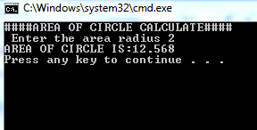

#include<iostream>

using namespace std;

long time_to_sec(int,int,int);

int hour;

int mint;

int sec;

long sec_time;

char col;

int main(){

char col;

cout<<"Enter the time in hour mint and sec";

sec_time=time_to_sec(hour,mint,sec);

cout<<"\n Enter the time";

cin>>hour>>col>>mint>>col>>sec;

return 0;

}

long time_to_sec(int hour,int mint,int sec){

sec_time=3600*hour+60*mint+sec;

return(sec_time);

}

#include<iostream>

using namespace std;

long time_to_sec(int hour,int mint,int sec){

long second;

second=3600*hour+60*mint+sec;

return(second);

}

void main(){

char col;

int hour,mint,sec;

cout<<"\n Enter the time";

cin>>hour>>col>>mint>>col>>sec;

cout<<"time in second"<<time_to_sec(hour,mint,sec);

}

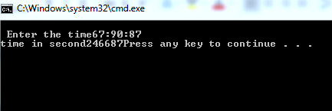

Another way to calculate the of circle

#include<iostream>

using namespace std;

double area;

double Area(const float pi,int rad){

area=pi*rad*rad;

return(area);

}

void main(){

int rad;

cout<<"\nEnter the radius for calculating area:";

cin>>rad;

cout<<"\nArea of circle is:"<<Area(3.142,rad);

}

